TRABALHO 2

Grafos – Percurso DFS

Larissa Magalhães Pereira

Nº USP: 13747904

1. Parte 1 em:

<https://colab.research.google.com/drive/1qMUOlmMa4TIV2ctkSdEY43MSiq5wh-ll?usp=sharing>

Para um grafo com as seguintes arestas: (0, 1), (1, 2), (2, 0), (2, 3), (1, 4), (5, 6), (6, 7), (7, 9), (6, 8)

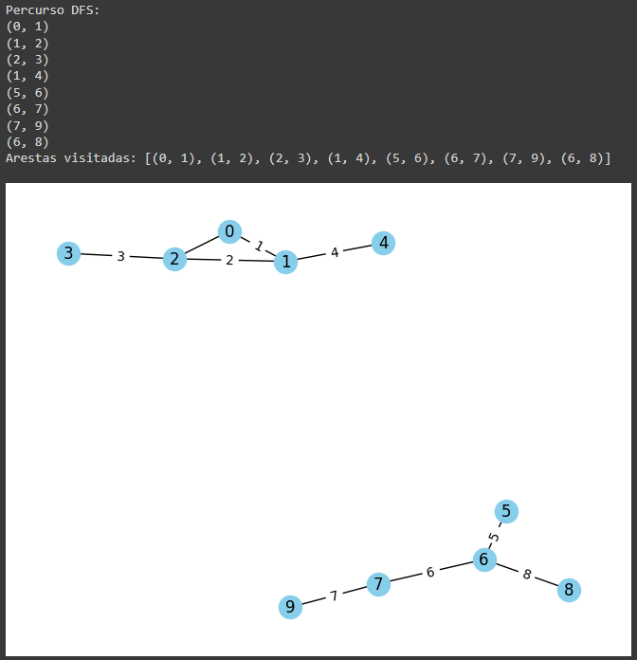

* 1. <https://chat.openai.com/share/dd44a9f8-e2e8-455c-989e-2274ced52e89>
  2. <https://chat.openai.com/share/190ce97c-f971-46e5-8c3f-62e97c2ebc4b>
  3. Parte 2 em: <https://colab.research.google.com/drive/1qMUOlmMa4TIV2ctkSdEY43MSiq5wh-ll?usp=sharing>

1. Parte 3 em: <https://colab.research.google.com/drive/1qMUOlmMa4TIV2ctkSdEY43MSiq5wh-ll?usp=sharing>